Original Article

Inhibitory effects of vegetable and fruit ferment liquid on tumor growth in Hepatoma-22 inoculation model

Ming Lu MSc¹, Yasushi Toshima MSc², Xiao-li Wu MSc¹, Xu Zhang PhD³ and
Yun-qing Cai PhD¹

¹Department of Nutrition and Food Hygiene, School of Public Health, Nanjing Medical University, China
²SHIMA Microbio Laboratory, Tokyo, Japan.
³Nanjing University of Chinese Medicine

The aim of this study was to determine the anti-tumor effect of vegetables and fruits ferment liquid (VFFL) in human hepatoma-22(H₂₂)-bearing mice. Mice bearing H₂₂ were randomly divided into four groups, that is a control group and three VFFL groups (16.7, 33.3 and 66.6 ml/kg). Inhibition rates of tumor, thymus and spleen index were observed. The apoptosis was analyzed by flow cytometry and the apoptotic body was observed under an electron microscope. A survival study was performed on the same model for the duration of 60 days. For this survival study, the mice were divided into five groups, which included a control group, three VFFL groups (16.7, 33.3 and 66.6 ml/kg) and a CP group. Tumor inhibition rates for VFFL16.7, 33.3 and 66.6ml/kg were 25.7%, 35.0 % (p<0.05) and 49.1 % (p<0.01) respectively at 30d, increasing in proportion to the concentration of VFFL given. Thymus and spleen indices of the VFFL groups were also higher than that of the control group. The apoptotic rates in VFFL 16.7, 33.3 and 66.6 ml/kg groups were 20.5%, 24.0% and 15.8% respectively, while it was only 6.82% in control group. In particular, the apoptotic body in the 66.6 ml/kg group exhibited typical apoptotic characteristics, e.g., condensation of nucleus, chromatin fragmentation, and shrinkage of cytoplasm. For the survival study, the mice in the VFFL 66.6ml/kg group exhibited significantly extended survival rates compared with the mice in the control group (p<0.05). This study concludes that VFFL possesses anti-tumor properties, which it exhibits by inducing apoptosis and prolonging life in H₂₂ tumor-bearing mice.

Key Words: vegetable and fruit ferment liquid, hepatoma-22, anti-tumor, apoptosis, survival study

Introduction
Fruits and vegetables are known to be effective in the prevention of cancer. They contain a multitude of compounds that have been shown to possess potentially cancer-preventive activity.¹ Numerous epidemiologic studies have examined the association between diet and cancer. One of the most consistent finds has been an inverse association between cancer and vegetable intake, in particular the intake of cruciferous vegetables.²⁻⁴ A high consumption of vegetables and fruits has been associated with a reduced risk of cancer, this in particular with lung cancers and epithelial cancers of the digestive tract.⁵⁻⁶ A statistically-significant inverse association with oral and pharyngeal cancer was found for the consumption of total green vegetables (OR 0.37) and total fruit (OR 0.34),⁷ while high consumption of cruciferous vegetables is associated with a reduced risk of prostate cancer.⁸
Our study explores the cancer-preventive effect of vegetables and fruits ferment liquid (VFFL). VFFL is a traditional health drink from Japan. It is a juice containing over 20 kinds of vegetables and fruits fermented in yeast. VFFL contains rich vitamins and botanically-active ingredients. Research indicates that the anti-tumor effect of a compound with multiple vegetables and fruits is stronger than that of a single component; and this may be related to the synergetic effect of multiple ingredients of vegetables and fruits.⁹ Fermented foods are abundant in polysaccharides and vitamins, substances which are beneficial to our health.¹⁰
The aim of our study is twofold: (1) to determine the protective effect of VFFL against tumor proliferation; (2) to explore its molecular mechanism of protection. Our study chose mice bearing hepatoma-22 (H₂₂) cells. H₂₂ cell lines are the most frequently used for in vivo anti-tumor research.^{11, 12}

Methods

Tumor Cell Lines and Inoculation Modeling

The H₂₂ cell line was purchased from Jiangsu Tumor Hospital in China. It was maintained by intraperitoneal passage through ICR mice (5×10⁶ cells/head). The male ICR mice, 6 weeks old and between 18g and 22g in weight, were purchased from the Laboratory Animal Research Centre in the Chinese Academy of Sciences (Shanghai, China.).

Corresponding Author: Professor Yunqing Cai, Department of Nutrition and Food Hygiene, School of Public Health, Nanjing Medical University, China, 210029
Tel: 86 25 86662941; Fax: 86 2586662930
Email: cai2941@163.com

The H₂₂ cells were washed with normal physiological saline for three times, adjusted to 1×10⁵ cells/ml and subcutaneously transplanted to each mouse via a 200uL injection.

Anti-tumor effect in H₂₂ bearing mice
Twenty-four hours after being administered with the H₂₂ tumor, the mice were divided into 4 groups. VFFL was given intragastrically (i.g.) to the test groups – in proportions of 66.6ml/kg, 33.3ml/kg and 16.7 ml/kg b.w. respectively. Physiological saline was given to the control group. This was done for the next 29 days on a daily basis. At the same time, tumor size was assessed in the mice every 5 days starting on the 5th day. This was done by measuring the maximum horizontal diameter (a) and the maximum vertical diameter (b) with a slide gauge. The tumor volume (A) was computed using the formula: A (mm²) =a*b. On the 30th day, mice were disposed of and the tumors and organs were isolated and weighed. The inhibition rate (IR) of the tumor is calculated as follows:

Analysis of apoptosis and cell cycles
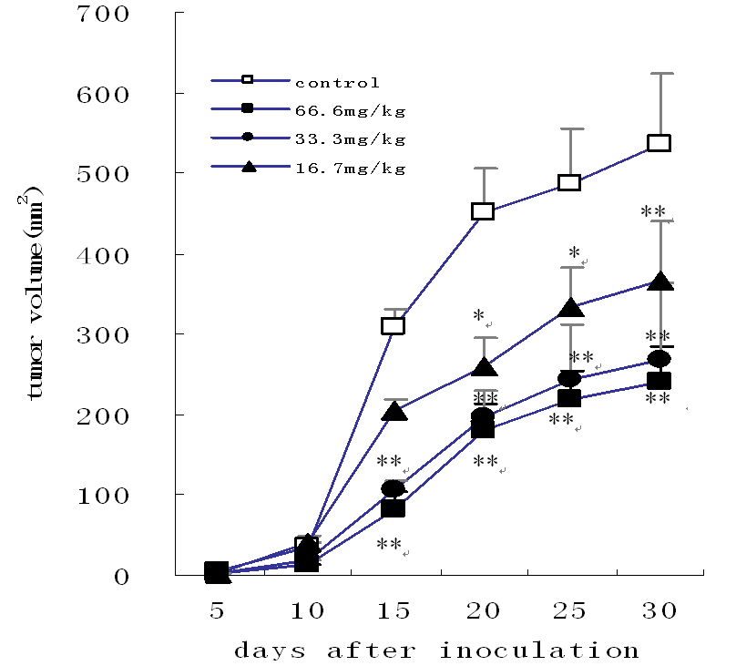
The tumor tissues were prepared into a single cell suspending fluid，fixed in 70% ethanol, and stored at 4°C overnight. The fixed cells were centrifuged and washed with PBS. They were stained with 1ml of 20 µg/ml propidium iodide and 1ml/ml RNAase in PBS for 15min. Later, the 1×10⁴ cells were examined by flow cytometry (FCM). The apoptotic cells and cell cycle were analyzed using FCM.¹³
control
66.6mg/kg
33.3mg/kg
16.7mg/kg*

Observation of apoptosis with electron microscopy
A portion of the tumor tissues was fixed in 4% paraformaldehyde and 1% osmic acid fixatives. The tissues were successively dehydrated in ethanol and embedded in Epon mixtures. Tumor sections (70 to 80 nm) were obtained with an ultramicrotome, stained with uranyl acetate and lead citrate. The apoptotic body was observed under a JEOL 1200-EX II electron microscope.

Survival study with H₂₂₋bearing mice
A survival study was performed by using another H₂₂₋bearing model that was similar to the model of anti-tumor experiment. This time around, the mice were divided into three VFFL treatment groups, a control group and a cyclophosphamide (CP) group. VFFL was given intragastrically (i.g.) to the mice from the treatment groups – in proportions of 66.6ml/kg, 33.3ml/kg and 16.7 ml/kg b.w. respectively. This was done on a daily basis. Physiological saline was used in the control group while 20mg/kg cyclophosphamide was used in the CP group, both for 7 straight days. The mice were observed daily and readings were taken until all the mice died.

Table 1. Effects of VFFL on tumor weight, thymus and spleen index in H₂₂-bearing mice (Mean ±SD)
Group | Dosage (ml/kg) | n | Thymus index (mg/g) | Spleen index (mg/g) | Tumor weight (g) | IR (%)
Control |  | 7 | 1.40±0.75 | 3.97±1.21 | 1.71±0.51
VFFL | 16.7 | 9 | 2.03±1.11b | 4.31±1.21 | 1.27±0.21b | 25.7
 | 33.3 | 9 | 1.51±0.32 | 5.18±1.10b | 1.11±0.41b | 35.0
 | 66.6 | 9 | 1.97±0.44 | 4.77±1.15 | 0.87±0.34a | 49.1
a: p <0.01, b: p <0.05 compared with control group

Statistical analysis
All values in this study were presented as Mean ± SD. The LSD analysis of variance (ANOVA) was used for the significance test, and a probability of less than 0.05 (p<0.05) was considered statistically significant. As for the survival study, it was performed using SPSS 11.5 survival analysis software.

Results
Change of tumor volume
After the mice bearing hepatoma-22 were administrated with VFFL, the tumor volume did not change significantly during the first 15 days. However, from day 15 until day 30, the tumor volume in the VFFL 66.6, 33.3 and 16.7 ml/kg groups showed a significant drop when compared with that of the control group (Fig 1).

Change of tumor weight, thymus and spleen index
The tumor weight of the three VFFL groups was significantly smaller when compared to control group. The tumor inhibition rate in the VFFL 66.6, 33.3 and 16.7 ml/kg groups was 25.7%, 35.0% and 49.1% respectively, exhibiting a dose-response relation. Both the thymus index in VFFL 16.7 ml/kg group and the spleen index in 33.3 ml/kg group were significantly larger when compared with that of the control group (Table 1).
CP

Control

16..7ml/kg

33..3ml/kg

66..6ml/kg*
Figure 1. Change of tumor volume in VFFL (16.7ml/kg, 33.3ml/kg, 66.6ml/kg, n=9) and control (n=7) groups (mean±SD). ** p<0.05 and p<0.01, VFFL group vs control group
Table 2 VFFL inducing apoptosis and change cell cycle in human H₂₂-bearing mice

Group | Dosage (ml/kg) | Apoptosis rate (%) | G₀-G₁ | S | M
Control |  | 6.82 | 66.7 | 26.8 | 6.5
VFFL | 16.6 | 20.5 | 30.5 | 55.8 | 13.7
 | 33.3 | 24.0 | 33.0 | 55.1 | 11.9
 | 66.6 | 15.8 | 25.9 | 62.1 | 12.1

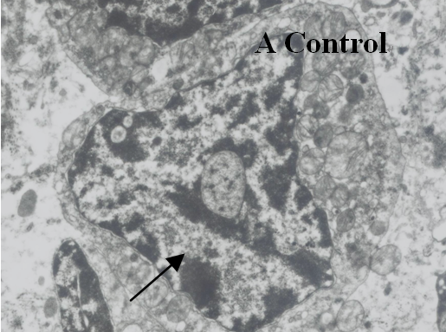

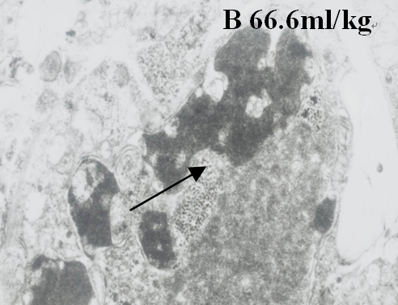

Figure 2. Electron micrographs for apoptosis body analysis (×8000).
Arrow: pointing to the place of apoptotic body.

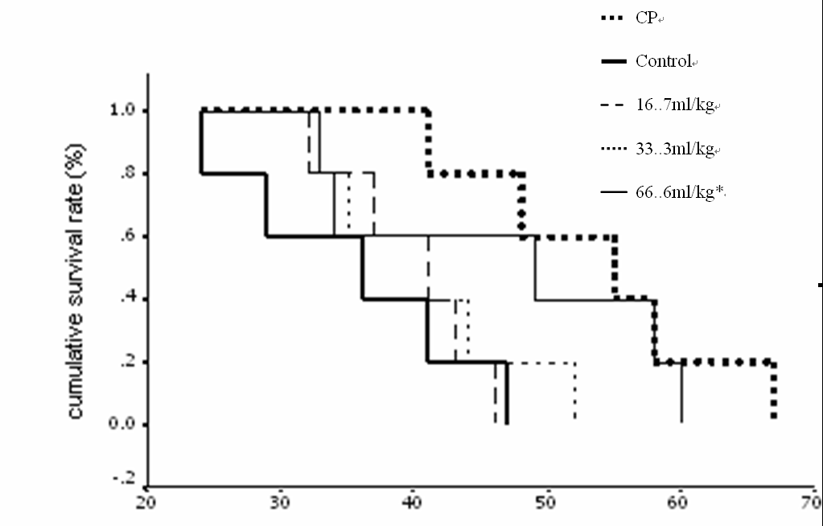

Figure 3. The survival time of mice administrated with VFFL.
The cell apoptosis and cycle change
To examine the mechanism of inhibition on H₂₂ tumor cell growth, apoptosis and cell cycle distribution were evaluated by flow cytometry. As shown in Table 2, VFFL is able to cause cell cycle arrest in the S-phase. The readings in Table 2 also show that the rate of apoptosis ranges from 15.8% to 24.0% in the three VFFL groups, but is only 6.82% in control group.

Electron micrographs
The hepatocyte structure in the control group exhibited standard tumor cell characteristics. A slightly swollen nucleus kernel, an indication of active DNA reproduction, was observed under an electron microscope. The hepatocyte structure in the VFFL 66.6ml/kg group exhibited a typical apoptotic structure. A complete nucleus with condensed chromatin and fragments distributed in the nuclear margin was observed. There was shrinkage of the cytoplasm and a round apoptotic body by the 30th day (Fig 2). There were also swollen and numerous vacuoles within its cytoplasm.

Survival study in H₂₂₋bearing mice
The survival time of H₂₂ mice in the VFFL 66.6ml/kg and the CP control group was significantly longer than that of the control group.(p<0.05; log-rank test). The VFFL 16.7 and 33.3 ml/kg groups also manifested an extended duration of survival. (Fig 3)

Discussion
Numerous investigations demonstrate that frequent intake of fruits and vegetables, ranging from daily to three times or more per week, may lower the risk of cancer.^{14, 15} A large number of potentially anti-carcinogenic agents are found in fruits and vegetables - these include carotenoids, vitamins C and E, selenium, folic acid, dietary fiber, dithiolthiones, isothiocyanates, glucosinolates, indoles, phenols, flavinoids, protease inhibitors, allium compounds, plant sterols and limonene. These agents have complementary and overlapping mechanisms of action, which include induction of detoxification enzymes, inhibition of nitrosoamine formation, dilution and binding of carcinogens in the digestive tract, alteration of hormone metabolism and antioxidant effects.¹⁶ Indeed, earlier research has demonstrated that nearly all of the antioxidant activity of fresh fruits on cell proliferation was derived from a mixture of phytochemicals rather than on vitamin C alone. The mixture of phytochemicals contained in fruits and vegetables is more effective than a single
CP
Control
16.7ml/kg
33.3ml/kg
66.6ml/kg*
antioxidant because the protective effect of fruits against cancer appears to depend on multiple constituent substances and mechanisms.^{17,18} The specific mechanism of how fruits and vegetables prevent carcinogenesis is unclear. However, much may be attributed in part to vitamin C and certain carotenoids, all efficient antioxidants which prevent damage caused by the peroxidation of free radicals to chromosomes, enzymes and cell membranes.¹⁹
Fermented foods are known to contain plenty of polysaccharides and functional vitamins. Some earlier studies show that the technique of fermentation may create unique metabolites by yeasts symbiosis, the end result of which is a mechanism enhancing human health.^{20, 21} Fermentation is a complex process and fermented diets consist of a broad range of fermentation products (e.g., lactic acid, acetic acid, ethanol, micro-flora, etc). The specific mechanism of how fermented foods prevent carcinogenesis is unclear, but it may be attributed in part to the metabolisis of certain substances. More research has to be done to ascertain the factor or combination of factors responsible for the positive consequence of fermented diets.
Our present study investigates the anti-tumor activity of VFFL, a drink made of fermented vegetables and fruits. Our results indicate that VFFL may inhibit proliferation and promote apoptosis of hepatoma. As known, apoptosis is an important mechanism in the cytocidal effect of anti-tumor drugs. Programmed cell death plays a critical role in many biological processes in multi-cellular organisms，for example embryonic development, immune response, tissue homeostasis and normal cell turnover. Deregulation of apoptosis has also been implicated in cancer. Although apoptosis is a complex process and its regulation is not completely understood, its critical role in the execution of tumor cell death is well-known.²² In any case, the study shows that the proportion of S phase cells in the VFFL-treated groups increased significantly. This suggests that by inhibiting transformation of hepatoma-22 from its G2-phase to its M-phase, VFFL is able to prevent hepatoma-22 proliferation through VFFL treatment for 30 days. The implication is that VFFL may be able to influence the cell cycle.
This study indicates that VFFL has an anti-tumor effect and an extended duration of survival in H22-bearing mice, which may associate with the inhibition of tumor cell growth and inducing apoptosis. The molecular mechanisms regarding the anti-tumor effect of VFFL will be studied further.

Acknowledgements
We acknowledge Zhao Yan and Chen Jian teachers from the School of Public Health, Nanjing Medical University, for their support during the animal experiment.

References
- Steinmetz KA, Potter JD. Vegetables, fruit, and cancer. II. Mechanisms. Cancer Causes Control 1991; 2: 427-442.
- Simth-Warner SA, Giovannucci E. Fruit and vegetable intake and cancer. In: Heber D, Blackburn GL, Go VLW, eds. Nutritional oncology. Boston, MA: Academic Press, 1999;153-183.

- Steinmetz KA, Potter JD. Vegetables, fruit, and cancer. I. Epidemiology. Cancer Causes Control 1991; 2: 325-357.
- Block G, Patterson B, Subar A. Fruit, vegetables, and cancer prevention: a review of the epidemiological evidence. Nutr Cancer 1992; 18: 1-29.
- Steinmetz KA, Potter JD. Vegetables, fruit, and cancer prevention: a review. J Am Diet Assoc 1996: 1027-1039.
- Ziegler RG, Mayne ST, Swanson CA. Nutrition and lung cancer. Cancer Causes Control 1996; 7: 157-177.
- Tavani, A, Gallus, S, La Vecchia, C, Talamini, R, Barbone, F, Herrero, R, Franceschi, S. Diet and risk of oral and pharyngeal cancer. An Italian case-control study. Eur J Cancer Prev 2001; 10:191-195.
- Cohen, Jennifer H, Kristal, Alan R, Stanford, Janet L. Fruit and Vegetable Intakes and Prostate Cancer Risk. Journal of the National Cancer Institute 2000; 92: 61-68.
- World Cancer Research Fund and American Institute for Cancer Research. Food, Nutrition and the Prevention of Cancer: a Global Perspective. Washington DC: American Institute for Cancer Research 1997; 436-446.
- Parvez, S, Malik, KA, Kang, S.Ah, Kim, HY. Probiotics and their fermented food products are beneficial for health. J Appl Microbiol 2006; 100: 1171–1185.
- Itoh, H, Amano, H., and Noda, H. Inhibitory action of a (1->6) beta-D-glucan-protein complex (F III-2-b) isolated from Agaricus blazei murill (“himematsutake”) on meth A fibrosar com-beazing mice and its anti-tumor mechanism. Jpn.J. pharmacol 1994; 66: 265-271.
- Lee, YL, Kim, HJ, Lee, MS, Han, JS, Hong, HK, Kwon, MS and Lee, MJ. Oral administration of Agricus blazei (H1 strain) inhibited tumor growth in a sarcoma 180 inoculation model. Exp.Anim 2003; 52:371-375.
- Ming Zhang, Shengping Li, Mukesh K. Nyati,Susan DeRemer, Joshua Parsels, Alnawaz Rehemtulla, William D. Ensminger, and Theodore S. Lawrence. Regional Delivery and Selective Expression of a High-Activity Yeast Cytosine Deaminase in an Intrahepatic Colon Cancer Model. Cancer Res 2003; 63:658-663.
- World Cancer Research Fund & American Institute for Cancer Research. Food, Nutrition and the Prevention of Cancer: a Global Perspective. Washington DC: American Institute for Cancer Research 1997; 436-446.
- Hong Jiang, Leonard Chess. An integrated view of suppressor T cell subsets in immunoregulation. J. Clin. Invest 2004; 114:1198-1208.
- Slattery ML, Kampman E, Samowitz W, Caan BJ, Potter JD. Interplay between dietary inducers of GST and the GSTM-1 genotype in colon cancer. Int J Cancer 2000; 87: 728-733.
- Eberhardt MV, Lee CY, Liu RH. Antioxidant activity of fresh apples. Nature 2000; 405: 903–904.
- Wattenberg LW. Inhibition of carcinogenesis by minor dietary constituents.Cancer Res 1992; 52: 2085S-2091S.
- Kato K, Akai S, Tominaga S, Kato I. A case-control study of biliary tract cancer in Niigata Prefecture, Japan. Jpn J Cancer Res 1989; 80: 932-938.
- Wattenberg LW. Inhibition of carcinogenesis by minor dietary constituents. Cancer Res 1992; 52: 2085-2091.
- Hajjar IM, Grim CE, George V, Kotchen TA. Impact of diet on blood pressure and age-related changes in blood pressure in the US population. Analysis of NHANES III 2001; 161: 589-593.
- Thompson Craig B. Apoptosis in the pathogenesis and treatment of disease. Science 1995; 267:1456-1462.

